

Introduction to NodeMCU ESP8266 12E with Arduino IDE

August 19th 2016

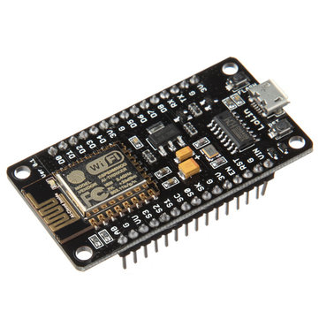

NodeMCU is an open source IoT platform. It includes firmware which runs on the ESP8266 Wi-Fi SoC from and hardware which is based on the ESP-12 module. We will use Arduino IDE to program our NodeMCU. To program NodeMCU we will use Arduino IDE.

Firstly open the Arduino IDE.  
Go to files and click on the preference in the Arduino IDE.

Copy the below code in the Additional Boards Manager.

http://arduino.esp8266.com/stable/package_esp8266com_index.json

Click OK to close the preference Tab.

After completing the above steps, go to Tools and board, and then select Board Manager.

Navigate to ESP8266 by ESP8266 community and install the software for Arduino.  
Once all the above process been completed we are ready to program our ESP8266 with Arduino IDE.

Pinout Diagram

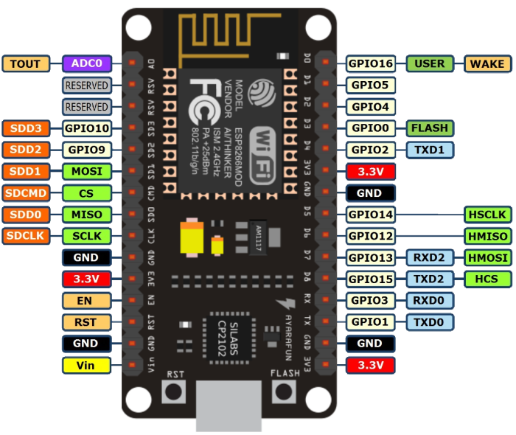

Uploading data using LM35 on Thingspeak.com

We will upload real time temperature data on a public channel using NodeMCU.

You will need a LM35 and 3 jumper wires for the circuit.

The circuit diagram for the project is given below.

